**Test Plan:**

* A test plan is a document that consists of all future testing-related activities. It is prepared at the project level and in general, it defines work products to be tested, how they will be tested, and test type distribution among the testers.
* It is shared with Business Analysts, Project Managers, and anyone associated with the project.

**Who writes Test Plans?**

Test Manager, Test Engineers, Test Lead

**Why are Test Plans Important?**

* **Quick guide for the testing process.**
* **Helps to avoid out-of-scope functionalities.**
* **Helps to determine the time, cost, and effort.**
* **Provide a schedule for testing activities.**
* **Test plan can be reused.**

**Objectives of the Test Plan:**

**Overview of testing activities:**

The test plan provides an overview of the testing activities and where to start and stop the work.

**Provides timeline:**

The test plan helps to create the timeline for the testing activities based on the number of hours and the workers needed.

**Helps to estimate resources:**

The test plan helps to create an estimate of the number of resources needed to finish the work.

**Serves as a blueprint:**

The test plan serves as a blueprint for all the testing activities, it has every detail from beginning to end.

**Helps to identify solutions:**

A test plan helps the team members They consider the project’s challenges and identify the solutions.

**Serves as a rulebook:**

The test plan serves as a rulebook for following rules when the project is completed phase by phase.

## ****Components and Attributes of Test Plan****:

It has 15 attributes.

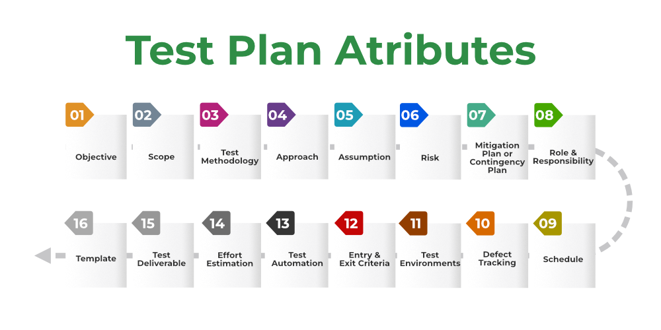

**Objective:**

* It describes the aim of the test plan, whatever the good process and procedure they are going to follow to give quality software to customers.
* The overall objective of the test is to find as many defects as possible and to make software bug-free.
* The test objective must be broken into components and sub-components. In every component following activities should be performed.
* List all the functionality and performance to be tested.
* Make goals and targets based on the application feature.

**Scope:**

It consists of information that needs to be tested concerning an application. The scope can be divided into two parts:

* **In-Scope:** The modules that are to be tested rigorously.
* **Out Scope:** The modules that are not to be tested rigorously.

**Testing Methodology:**

* The methods that are going to be used for testing depend on application to application.
* The testing methodology is decided based on the feature and application requirements.

**Approach:**

It deals with the flow of applications for future reference. It has two aspects:

* **High-Level Scenarios:** For testing critical features high-level scenarios are written. For Example, login to a website, and book from a website.
* **The Flow Graph:**It is used when one wants to make benefits such as converging and merging easy.

**Assumption:**

In this phase, certain assumptions will be made.

**Example:**

* The testing team will get proper support from the development team.
* The tester will get proper knowledge transfer from the development team.
* Proper resource allocation will be given by the company to the testing department.

**Risk:**

All the risks that can happen if the assumption is broken. For Example, in the case of wrong budget estimation, the cost may overrun. Some reason that may lead to risk is:

* Test Manager has poor management skills.
* Hard to complete the project on time.
* Lack of cooperation.

**Mitigation Plan:**

If any risk is involved then the company must have a backup plan, the purpose is to avoid errors. Some points to resolve/avoid risk:

* Test priority is to be set for each test activity.
* Managers should have leadership skills.
* Training course for the testers.

**Roles and Responsibilities:**

All the responsibilities and role of every member of a particular testing team must be recorded.

**Example:**

* **Test Manager:**Manages the project, takes appropriate resources, and gives project direction.
* **Tester:** Identify the testing technique, verify the test approach, and save project costs.

**Schedule:**

Under this, it will record the start and end date of every testing-related activity. For Example, writing the test case date and ending the test case date.

**Defect Tracking:**

It is an important process in software engineering as lots of issue arises when you develop a critical system for business. If there is any defect found while testing that defect must be given to the developer team. There are the following methods for the process of defect tracking:

* **Information Capture:**In this, we take basic information to begin the process.
* **Prioritize:**The task is prioritized based on severity and importance.
* **Communication:** Communication between the identifier of the bug and the fixer of the bug.
* **Environment:** Test the application based on hardware and software.

**Example:**The bug can be identified using bug-tracking tools such as Jira, Mantis, and Trac.

**Test Environments:**

It is the environment that the testing team will use i.e., the list of hardware and software, while testing the application, the things that are said to be tested will be written under this part. The installation of software is also checked under this.

**Example:**

* Software configuration on different operating systems, such as Windows, Linux, Mac, etc.
* Hardware Configuration depends on RAM, ROM, etc.

**Entry and Exit Criteria:**

The set of conditions that should be met to start any new type of testing or to end any kind of testing.

**Entry Condition:**

* Necessary resources must be ready.
* The application must be prepared.
* Test data should be ready.

**Exit Condition:**

* There should not be any major bugs.
* Most test cases should be passed.
* When all test cases are executed.

**Example:**If the team member reports that 45% of the test cases failed, then testing will be suspended until the developer team fixes all defects.

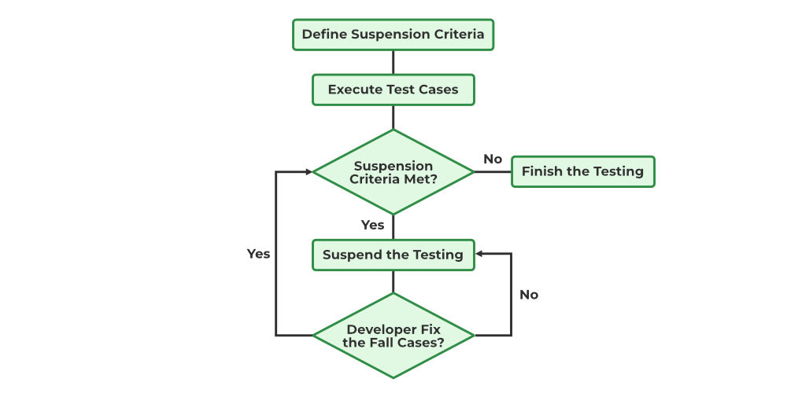

*Example of Test Plan*

**Test Automation:**

It consists of the features that are to be automated and which features are not to be automated.

* If the feature has lots of bugs, then it is categorized as Manual Testing.
* If the feature is frequently tested, then it can be automated.

**Effort Estimation:**

This involves planning the effort that needs to be applied by every team member.

**Test Deliverables:**

It is the outcome from the testing team that is to be given to the customers at the end of the project.

Before the testing phase:

* Test plan document.
* Test case document.
* Test design specification.

During the testing phase:

* Test scripts.
* Test data.
* Error logs.

After the testing phase:

* Test Reports.
* Defect Report.
* Installation Report.

It contains a test plan, defect report, automation report, assumption report, tools, and other components that have been used for developing and maintaining the testing effort.

**Template:**

This is followed by every kind of report that is going to be prepared by the testing team. All the test engineers will only use these templates in the project to maintain the consistency of the product.

## ****How to create a Test Plan****:

## There are eight steps should follow to write test plan:

## create-test-plan

**1. Analyze the product:**

This phase focuses on analyzing the product, Interviewing clients, designers, and developers, and performing a product walkthrough. This stage focuses on answering the following questions:

* What is the primary objective of the product?
* Who will use the product?
* What are the hardware and software specifications of the product?
* How does the product work?

**2. Design the test strategy:**

The test strategy document is prepared by the manager and details the following information:

* Scope of testing which means the components that will be tested and the ones that will be skipped.
* Type of testing which means different types of tests that will be used in the project.
* Risks and issues that will list all the possible risks that may occur during testing.
* Test logistics mentions the names of the testers and the tests that will be run by them.

**3. Define test objectives:**

This phase defines the objectives and expected results of the test execution. Objectives include:

* A list of software features like functionality, GUI, performance standards, etc.
* The ideal expected outcome for every aspect of the software that needs testing.

**4. Define test criteria:**

Two main testing criteria determine all the activities in the testing project:

* **Suspension criteria:**Suspension criteria define the benchmarks for suspending all the tests.
* **Exit criteria:**Exit criteria define the benchmarks that signify the successful completion of the test phase or project. These are expected results and must match before moving to the next stage of development.

**5. Resource planning:**

This phase aims to create a detailed list of all the resources required for project completion. For example, human effort, hardware and software requirements, all infrastructure needed, etc.

**6. Plan test environment:**

This phase is very important as the test environment is where the QAs run their tests. The test environments must be real devices, installed with real browsers and operating systems so that testers can monitor software behaviour in real user conditions.

**7. Schedule and Estimation:**

Break down the project into smaller tasks and allocate time and effort for each task. This helps in efficient time estimation. Create a schedule to complete these tasks in the designated time with a specific amount of effort.

**8. Determine test deliverables:**

Test deliverables refer to the list of documents, tools, and other equipment that must be created, provided, and maintained to support testing activities in the project.

## Deliverables required before testing: Test plan, Test Design

## Deliverables required during testing: Test Scripts, Simulators, Test Data, Error and

## Execution logs

## Deliverables required after testing: Test Results, Defect Reports, Release Notes

## 